

Smart Phone Controlled 4WD Robot Car

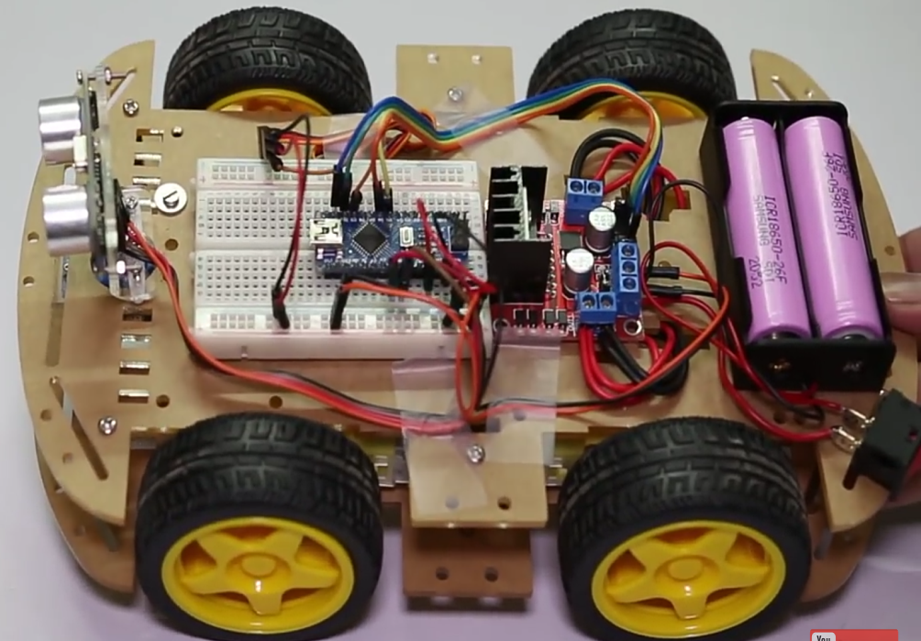

A Model On

**Smart Phone Controlled 4WD Robot Car**

Built by- Aman Kumar (146402)

Anand Kumar Sharma (146404)

D. Agam (146408)

Gaurav Jain (146411)

Pravendra Sisodhiya (146419)

Rahul Kumar (146420)

Ramkrishan Pandey (146422)

Ravi Ranjan (136813)

Kunal Modi (146833)

ELECTRONICS

3RD YEAR

TECHNICAL COLLEGE

DAYALBAGH EDUCATIONAL INSTITUTE

DAYALBAGH, AGRA - 5

Introduction-

Bluetooth controlled car is controlled by using Android mobile phone instead of any other method like buttons, gesture etc. Here only needs to touch button in android phone to control the car in forward, backward, left and right directions. So here android phone is used as transmitting device and Bluetooth module placed in car is used as receiver. Android phone will transmit command using its in-built Bluetooth to car so that it can move in the required direction like moving forward, reverse, turning left, turning right and stop.

Components List-

1. DC Motor
2. Bread Board
3. Lithium Ion Battery
4. Arduino UNO R3 (Microcontroller)
5. HC – 06 (Bluetooth to UART Converter COM Serial Communication Slave Mode)
6. HC – SR 04 Ultrasonic Distance Measuring Sensor
7. LM 298 H Bridge Module (Motor Driver)
8. Male Female Jumper Wire
9. Male Male Jumper Wire
10. DC Servo Motor

Tools Required-

1. Scale
2. Paper Cutter
3. Scissor
4. Hot Glue Gun
5. Drill Machine
6. Wires
7. Wire Cutter
8. Wire Insulator
9. Screw Driver Set
10. Plier
11. UNO Cable

Soldering tools-

1. Soldering iron
2. Soldering wire
3. Soldering iron stand
4. Flux

Programming tools-

1. A Personal Computer or Laptop
2. Android phone
3. Arduino Car Control App
4. Arduino Software and Driver

Theory-

1. Arduino UNO R3
2. Microprocessor
3. HC-06 Bluetooth module
4. LM-298 DUAL H-Bridge Motor Driver
5. HC-SR04 Ultrasonic Ranging Sensor
6. Servo Motor
7. PWM Motor
8. Arduino Programming
9. Project Explanation